Introduce Yourself

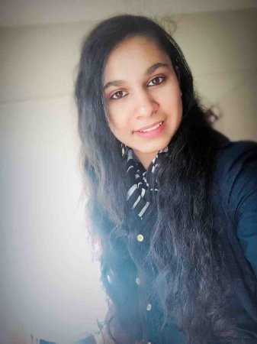

Linkedin: <https://www.linkedin.com/in/7979-amanpreet-k-b-/>

I am Amanpreet Kaur Bassi, currently an international student at SUNY New Paltz with a Computer Science major. I am a transfer student from SUNY Orange County Community College holding an Associates in Computer Science. Coming from a computer-based background, I have taken a lot of programming courses; Introduction to python, C, C++, Assembly, Data Structures, Computer Science I & Computer Science II, III and java programming. I always like to do things on my own and teach myself from my mistakes, so I research deeply into subjects to increase my knowledge and skills. Throughout my student life, I have maintained a good academic excellence record and I hope to continue it with high spirits, by the grace of God. My merits include hard working, looking beneath what’s visible to the eye, thinking outside of the box, always having multiple strategies for every problem, helping others and myself, dedicated, ambitious, patient and honest. As everyone, I also have things to fix in myself and I am still working on them. One of my main flaws include that sometimes I would not try out something unless I have a deeper understanding of what I am doing. For example, if someone says, “This is what you need to do; memorize it and keep applying it.” I would not do it until I fully understand it. It’s not that I am not good at memorizing, but I need to know the reason behind what’s happening and how was it formulated or what’s its purpose. And sometimes, this turns out to be a big disadvantage for me because while other students just keep working on future projects, I am still looking for my answers to these questions. Even reaching out to teachers in person have not worked out most of the times. Individually, I like to focus on every aspect of my life; whether its related to studies, work, home, community services, or religious obligations. By profession, I have worked as a tutor for almost 2 years at my previous college for most of the science and math courses. Recently, I completed an internship with ID-Tech where I worked as an instructor, teaching Artificial intelligence and machine learning. As a person, I am true believer of One God and that he is found every being and everything that surrounds us. I like to play my duties towards our society to satisfy my soul.

My goals towards this class are very high. I would like to share with you that I was in fifth grade when HTML first got available to students at our school and I still remember the little project that I made at the end of the course. It was a webpage with information about how computers would be like, in future. I was given an excellence award by my teacher because it was artistic, professional and he couldn’t believe that I made it at that age, there was no CSS at that time or maybe we didn’t know it existed. After that I was never able to take any such courses. Now, that I saw this class I am really excited to work hard to bring my artist back. While going through the course material, I found out that it’s a lot of self-learning and hard work. But with your help and guidance, I hope to fulfil my goals towards this class. I look forward to work with you. By the end of the course, I am positive I will learn a lot, while you share your knowledge with us.